DT-ENG-471/TD7-V1 / 201811

2 WIRE VIDEO SYSTEM

DT471-TD7

7" VIDEO HANDS-FREE COLOR TFT MONITOR

· Please read this manual carefully before using the product you purchase,and keep it well for future use.
· Please note that images and sketch maps in this manual may be different from the actual product.
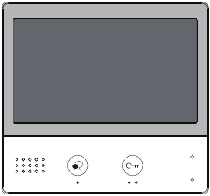

PRECAUTIONS

· Slots or openings in the back of the monitor, are provided for ventilation and to ensure reli-
able operation of the video monitor or equipment and to protect it from overheating. These
openings must not be blocked or covered. The monitor should never be placed near or over
a radiator or heat register and should not be placed in a built-in installation such as a book-
case unless proper ventilation is provided.
· All parts should be protected from violence vibration. And not allow be impacting, knocking
and dropping.
· For clean the LCD screen, using hands or wet cloth is forbidden.
· Please do the cleanness with soft cotton cloth, please do not use the organic or chemical
detergent. If necessary, please use pure water or dilute soap water to clean the dust.
· Image distortion may occur if the video door phone is mounted too close to magnetic field e. g.
Microwaves, TV, computer etc.
· Please keep away the video door monitor from wet, high temperature, dust, and caustic and
oxidation gas in order to avoid any unpredictable damage.
· Do not open the device in any condition, call the administrator for help if there is any prob-
lem.

CONTENTS

Front panel ............................................................................................................................ 1
Mounting ............................................................................................................................... 2
Screen.................................................................................................................................... 3
Answering a call ................................................................................................................... 4
Pan-tilt & Zoom ..................................................................................................................... 5
Adjusting screen&volume ................................................................................................... 6
Door release.......................................................................................................................... 7
Calling other monitors ......................................................................................................... 7
Monitoring ............................................................................................................................. 8
Recording.............................................................................................................................. 9
Viewing images/videos ....................................................................................................... 10
Don't disturb function ......................................................................................................... 10
Divert call ............................................................................................................................. 11
How to get QR code ............................................................................................................ 11
Download Setup 2Easy APP............................................................................................... 12
Surveillance door station via 2Easy APP .......................................................................... 14
Openning staircase light..................................................................................................... 15
Setting rong tone................................................................................................................. 15
Setting ring volume ............................................................................................................. 16
Setting monitor time............................................................................................................ 16
Enabling/Disabling intercom function .............................................................................. 17
Delete all images/video ....................................................................................................... 17
Restoring to default setting................................................................................................ 18
Entering installer setup....................................................................................................... 18
Specification ........................................................................................................................ 22

Front panel

LCD Screen

Speaker

Talk/Mon Button

POWGNDRINGSW-SW+

Power/No Disturb Indicator
Microphone
Unlock Button

ON
DIP

123456
Connection port

L1
L2

Key functions

-1-
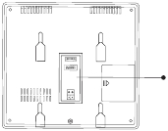

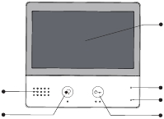

Speaker | · Send out vioce from the visitor.
Talk/Mon button | · Press to communicate hands free with visitor;· Press to view the outdoor condition in standby mode.
LCD screen | · Display the visitors' image.
Power/No Disturb indicator | · Show the power status of the system.· Show the no disturb status.
Microphone | · Transmit audio from one station to other stations.
Unlock button | · Press to release the door.
Connection port | · Bus terminal, Setting the monitor's address.

Mounting

Mounting box

The unit

Mounting screw
x 2(included)
2 wire cable
Mounting bracket

The installation height is suggested to 145~160cm.
1. Use screws to fasten the mounting bracket to the wall with mounting box.
2. Connect the 2 wire cables to the unit.
3. Mount the unit to the mounting bracket, make sure the unit is absolutely attached to the
mounting bracket.

Terminal description

SW+,SW-: Extra door
port.

bell call button connection

Ring,GND: Extra buzzer connection port.
POW,GND: 12~16V extra power connection port.
DIP switches: Total 6 bits can be configured.
POW GND RING SW- SW+
ON DIP
123456

· Bit1~Bit5:
User Code setting switch.

· Bit6:
Video impedance matching switch.

L1,L2: Bus
line terminal.

L1

L2

-2-
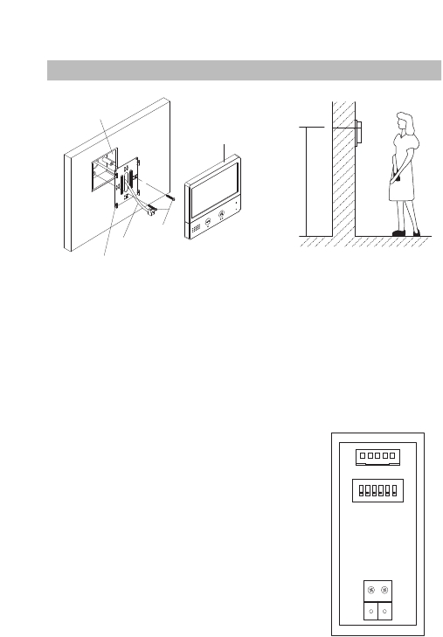

145~160 cm

Screen

Main Menu
The Main menu is your starting point for using all the applications on your monitor.
Touch anywhere of the screen on monitor in standby mode, the Main menu will appear as follow:

Monitor
Touch it to view outdoor condition.
Touch this icon to directly
enable/disable the don't disturb and
divert function.

Playback
Touch it to play recorded images or videos
from door stations.

While talking with a door station

Displays which door station
is calling.

Intercom
Touch it to enter intercom selections.

Light
Touch it to light up the staircase light
via RLC.
Close
Touch it to turn off the screen and
make the monitor in standby mode.

Setting
Press it to enter setup interface.

Shows status of talking,unlocking
ect.

Displays talking time.

00:10

DS1

This function needs the fisheye
camera support.

-3-
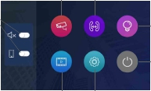

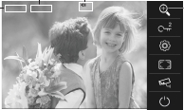

Answering a call

00:10

Door Station1

· When there is a call from a video door station. The call tone sounds, an image will be dis-
played on the screen.

· Press

TALK/MON button on the panel, begin communicating hands free with the visitor

for 90 seconds.
· While communicating with the visitor, unlock the door, capture images/videos and adjust
screen&volume are available. More details,please refer to the following descriptions.
Note: If nobody answers the phone, the screen will be turned off automatically after 40 seconds.

Monitoring cameras while being called/talking
It’s available to select cameras to monitor while being called.
Follow the steps:

00:10

DS-1

00:13

DS-2

00:06

DS-3

Notes: Press
eras.

-4-

icon to cycle switch the camera if the system installs multi door stations/cam-

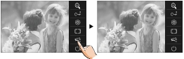

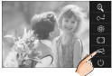

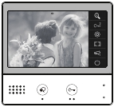

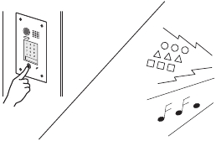

Adjusting image scale while being called/talking
It’s available to adjust image scale while being called. Total 2 image modes can be selected.
Follow the steps:

00:10
DS-1
00:10
DS-1
00:10
DS-1

Normal

To complete communication

Normal

· Touch

icon on screen or press the

TALK/MON button on the panel to complete the

communication.
Note: Communication also ends automatically after 90 seconds.

1.Receiving a call while talking with a door station
· Other door stations calling is forbidden
· Conclude current talking to answer the new call-in

2.Receiving a call while talking with other monitors
· The talking will stop immediately, call tone sounds in normal.
· The video image from the door station is displayed on the screen, talking,unlock,capture
images/videos, adjust screen&volume are available.

Panview & Zoom

It is available to adjust the display mode for viewing images at a fish-eye door station.

When an image at a door station is

00:10

DS-1

00:10

DS-1

displayed, touching
on the screen

to view the image in zoom mode.

Note:
1.The zoom&pantilt function should make effective with fish-eye door station.
2.The edge of pantilt image will not be displayed.

-5-
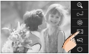

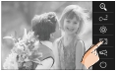

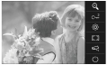

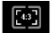

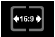

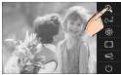

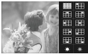

Adjusting screen&volume

While receiving a call from door station, or monitoring /communicating with the visitor,you can
adjust the screen and speaker volume. Follow the steps:

00:10
DS-1
00:10
DS-1

3
4
5
6

Adjusting images
Total 3 scene modes can be selected in sequence:Normal, Brightly and Soft.Whichever mode
you choose, there will be a corresponding value for contrast,brightness and color.
You should know that the contrast,brightness and color can be modified freely.

Adjust the contrast of the screen,the range is 0~9. Touch - or + to change the level.

Adjust the brightness of the screen ,the range is 0~9. Touch - or + to change the level.

Adjust the color of the screen,the range is 0~9. Touch - or + to change the level.

Note: The adjustments have no effect on the recorded images.

Adjusting the speaker volume
Volume can be adjusted at any time.
Adjusting range: 0 - 9.
Touch - or + to reach desired level.

-6-
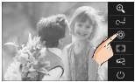

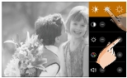

Door release

It is available to release the door during a call-in, communication,or while monitoring a door
station.

Press
UNLOCK button on panel to
00:10
DS-1

release door. The door lock is released for
the set door release time.
(if two locks are connected to door station,

touch
2
icon to release the second lock.)

Calling other monitors

It is available to call between monitors in the same room or in the same system,or call the
Guard Monitor.Follow the steps to activate the functions:

00:10

DS-1

Calling monitors you want

Touch
icon, then input the room code to call the monitor you want.

Calling monitors in the same room

Touch
icon on one of monitor, all other monitors in the same room will ring at the same

time,whichever monitor answers the call, conversation is started, other monitors will stop ringing
at once.
Note:1.the DIP switches setting of all monitors must be same.
2.Calling ends automatically after 30 seconds if nobody answers the call.

-7-
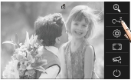

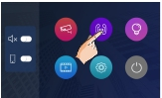

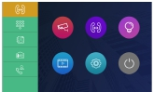

Calling other monitors in the same system

Touch
icon on monitor, the users in the same system will be displayed. Just select one target

to call the corresponding user. If the call is answered,conversation is activated.

00:10

DS-1

JAMES
WEDE
BOSH
PAUL

Note:

* Use "
" to scroll pages.

* Calling ends automatically after 30 seconds if nobody answers the call.

Calling the guard monitor

A Monitor can be assigned as Guard Unit Monitor; Touch
icon to activate the communication

with guard station when the Guard Unit Monitor answers the call, conversation with the guard
person is started.

Monitoring

You can monitor the entrance at any time via the monitor.
1.Touch anywhere of the screen on monitor in standby mode.

2.Touch
*Note: Press
icon on main menu page to enter Monitor select page.
TALK/MON button on panel in standby mode to monitor the master door station in shortcut.

Monitoring door stations/cameras:
· It can be selected to monitor individually if the system installs multi door stations/cameras.
See the following steps:

DS-1

00:12

DS-1
DS-2
DS-3
DS-4

* During monitoring, images can be viewed, but audio cannot be heard.

* If there is a visitor at the entrance, press the
munication with door station.

-8-
TALK/MON button on the panel to begin com-

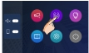

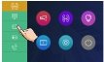

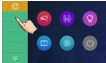

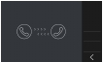

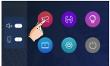

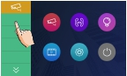

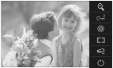

3.To end monitoring

Touch
icon on the screen or press
TALK/MON button on panel.

* Monitoring also ends automatically after 30 seconds.

Available functions during monitoring(not including video quad monitoring)
· Pantilt & zoom
· Adjusting images(image scale/bright/color/contrast)
· Door release
· Volume control

Recording

This function needs the IPG support.
Videos and images are possible to be recorded by automatic recording.

Automatic recording

00:10

DS1

· Recording starts after 3 seconds while
receiving a call.
· Capture one picture automatically for
each calling.

The recorded images are stored in the built-in memory first.
* Max.200 pictures can be stored in inner memory
* If a micro-SD card is installed, images can be copied to SD card.
* Max. 32G Micro SD card is supported.
Note:
* Automatic recording function can be forbidden.
* Automatic recording is not available while monitoring a door station.

-9-

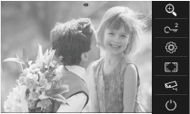

Viewing images/videos

The recorded images/videos can be playback on monitor. Follow the steps:

Video:008/020

2015/06/23

14:36:55

· Touch " " or "

" to scroll through recordings, touch “

” to delete current image/

video(Please note that if the recordings are videos, touch " " icon to start/pause the videos).

Don't disturb function

If you don't want to be disturbed,for example,at night. Activating the don’t disturb function is
necessary for you. Follow the steps:

Do Not Disturb: If you select this mode, calling from door station or other monitors can not be
made effect.

-10-
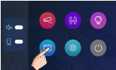

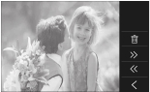

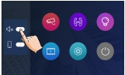

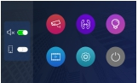

Divert call

The calling from door station can be diverted to your phone. please note that this function
should be supported by the unit of IPG. Follow the steps to activate this function:

Two modes can be selected.
1. When both the divert function and the don’t disturb function are activated, the divert mode is
Divert, immediately.
When receives call from door station, diverts the call to the phone immediately.
At this mode,the monitor will always close the screen and show image from door station during
diverted, if the monitor answers the call at this time,diverted will conclude at once.

2. When the divert function is activated and the don’t disturb function is turned off, the divert
mode is Divert, If No Answer.
If nobody answers the call in 30s when receives call from door station, diverts the call to the
phone.
At this mode, the monitor will shut off the screen after diverting successfully, but you can still
use it in normal.
Note:
* The time limited with the phone is 90s.

How to get QR code

Press it could
change
password

-11-
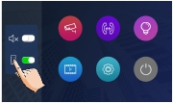

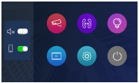

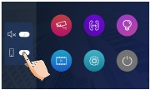

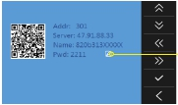

Download Setup 2Easy APP

1. Scan and download 2Easy APP, or search “2Easy” on APP store.

IOS

Android

2. Permit “2Easy” with internet access and camera, on monitor, in QR code page , and keep in
QR code page. on 2Easy APP, press on top-right, to scan QR code on monitor, and press “Save”.

-12-
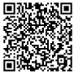

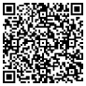

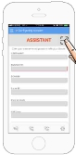

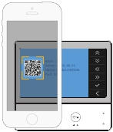

3. Disable “IPV6” on 2Easy APP
Most of internet provide doesn’t support IPV6 feature, please manually disable it with follow steps:

Press here
to disable

-13-
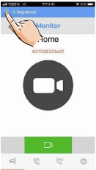

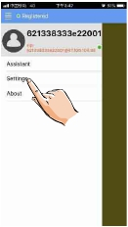

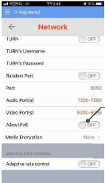

4. After login SIP account on 2Easy APP, check on status bar, or press on the “Registered” area
to manually register, until 2Easy APP display:

Surveillance door station via 2Easy APP

· On 2Easy APP, press on “Monitor” and wait for a few second (Due to 2-Wire communication
will take around 12 second to get video), blue screen is normally due to the monitor is verify-
ing the password and monitor code.

-14-
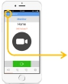

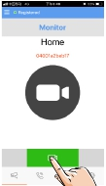

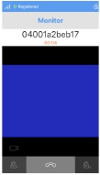

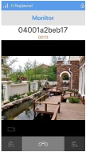

Opening staircase light

Note: The staircase light should be connected on the system, and this function should be sup-
ported by RLC. Please refer to RLC user instruction in detail.

Touch
icon on main menu page to open the staircase light, the staircase light will be turned

off automatically after 60 seconds.

*Touch

icon again to turn off the light.

Setting ring tone

The ring call tone can be set individually to distinguish different calling sources. Total 12 tones
can be selected.

1.On main menu page, touch
icon -> touch
icon.

2.Touch the setting target of door tone,intercom tone,alert tone individually, then touch
icon to change the tone. Settings will perform immediately.
/

01

01

01

01

11
06

Note: 1. Touch

icon, the door ring mode is selected to United, the ring tone of Door1/2/3/4 must be the same.

2. Touch
icon to exit and return to main menu page.

-15-

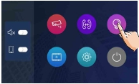

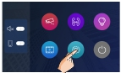

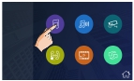

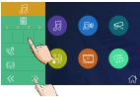

Setting ring volume

The ring volume can be set individually. The setting range is 0~9.

1.On main menu page, touch
icon -> touch
icon.

2.Touch
/
icon to adjust the levels. Settings will perform immediately.

1

Note: 1.If the level is 0, it means that mute states (when receive the call from door station).

2.Touch
icon to exit and return to main menu page.

Setting monitor time

The monitor time can be changed. It's available to set 6s,10s,20s,30s,40s,50s,1min,2min,3min,
4min,5min,6min,7min,8min,9min,10min.
* 30s is the default monitor time.

1.On main menu page, touch
icon -> touch
icon.

2.Touch
/
icon to adjust the levels. Settings will perform immediately.

50sec

-16-
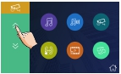

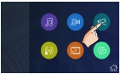

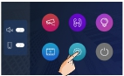

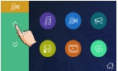

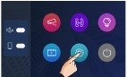

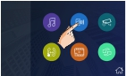

Enabling/Disabling intercom function

You can enable or disable intercom function from this monitor.

On main menu page, touch
icon -> touch
icon.

Note: *In default setting, intercom function is enable for the monitor.

*
*
means that the intercom function is forbidden.
means that the intercom function is Enabling.

Delete all images/video

You can delete all images/video from this monitor.

1.On main menu page, touch
icon -> touch
icon.

2.Touch
icon, a message will be asked.

3.Touch
icon to start the restore. Touch
icon to cancel.

-17-

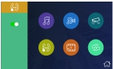

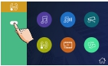

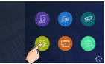

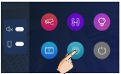

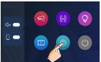

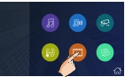

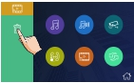

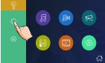

Restoring to default setting

The restore to default function allows the user to recover the settings to factory setting.

1.On main menu page, touch
icon -> touch
icon.

2.Touch
icon, a message will be asked.

3.Touch
icon to start the restore. Touch
icon to cancel.

* If restoring to default is completed,a sound beep will be sent out.

Entering installer setup

· On main menu page, touch

icon.

· When the screen stay in About page, press
3 seconds.
· A keypad is shown.
Refer to the followings:

Ver:
00.01.00
Addr:
01.10
Video:
AUTO

-18-
UNLOCK button on front panel and hold for

[0000]
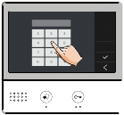

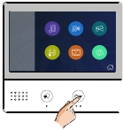

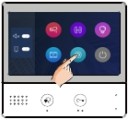

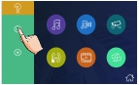

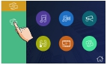

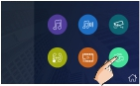

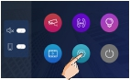

The setting code and items

Setting as a Guard Monitor

A Monitor can be assigned as Guard Unit Monitor; when the Guard Unit Monitor answers the
call, conversation with the guard person is started..
· The code of 8004 is used to set the monitor as a guard unit monitor.
· The code of 8005 is used to cancel this function.

Setting date and time format

The system offers two ways of date and time.
· The code of 8008 is used to set the date format as month/date/year.
· The code of 8009 is used to set the date format as date/month/year.
· The code of 8012 is used to set the time format as 12 hour system.
· The code of 8013 is used to set the time format as 24 hour system.

-19-
Code | Setting Item | Code | Setting Item
2419 | Restore To Default | 8016-8017 | Bypass Enable/Disable
2500-2549 | RM Parameter Set | 8018-8020 | Video Format
8000-8003 | Setting master/slave monitor | 8401-8499 | Unlock Time
8004-8005 | Guard Unit Enable | 8505-8520 | Divert Time
8006-8007 | Panel On/Off | 9017-9018 | Memory On/Off
8008-8009 | Date Mode | 9030-9031 | Doc. Function On/Off
8010-8011 | Unlock Mode:Close/Open | 9101-9104 | Door Station Quantity
8012-8013 | Time Mode:12 hour/24 hour | 9200-9216 | Camera Quantity

Setting unlock parameter

Unlock mode:

There are two unlock modes: 1.power-on- to-unlock type:unlock mode=0(by default)
2.power-off-to-unlock:unlock mode=1.
· The code of 8010 is used to set the unlock mode to 0
· The code of 8011 is used to set the unlock mode to 1

Unlock time:
· The unlock time can be changed by yourself at any time. it can be set from 1 to 99 seconds.
· The code from 8401 to 8499 are used to set the unlock time to 1~ 99 seconds.

Setting user code

On DT system,every apartment must assign a unique identification called User Code.

DIP Switcher Set Address
The DIP switches are used to set the user code for each monitor.Total 6 bits can be configured.
· Bit-1 to Bit-5 are used for user code setting. The value range is from 0 to 31, which have 32
different codes for 32 apartments.

-20-

In the DT system,every apartment must have a unique identification called User Code.
The DIP swiches are used to configure the User Code for each Monitor.
· Bit-1 to Bit-5 are used to User Code setting. The value is from 1 to 32, which have 32
· different monitors apartments.installed in one apartment, these monitors should use the
· When multicode,Monitorsthearemaster/slave modeapartment,bethese Monitorsmonitor. (Detailsthe same
the section of Setting Slave Master/Slave mode should be set on the Monitor.
· Bit-6 buslinelineterminal switch, which shouldbebesetset ON“ON”the Monitor is in the endendthe
line(bus), otherwise set to “OFF”.The end of the line is terminal that no other section will
start from it.
Bit-6switchterminal setting:

ON DIP
ON 1 2 3 4 5 6
1 2 3 4 5 6

ON
ON(1)
ON(1)
=ON
=
OFF(0)
OFF(0)
ON
=ON
=

1 2 3 4 5 6

the end of the
line.

1 2 3 4 5 6

the end of
the line.

-21-
Bit state |  | User Code | Bit state |  |  |  |  |  |  | User Code | Bit state |  |  |  |  |  |  | User Code
 | ON1 2 3 4 5 6 | Code=1 | ON1 2 3 4 5 6 |  |  |  |  |  |  | Code=12 |  | ON1 2 3 4 5 6 |  |  |  |  |  | Code=23
ON1 2 3 4 5 6 |  | Code=2 | ON1 2 3 4 5 6 |  |  |  |  |  |  | Code=13 |  | ON |  |  |  |  |  | Code=24
 |  |  |  |  |  |  |  |  |  |  |  | 1 2 3 4 5 6 |  |  |  |  |  | Code=24
ON1 2 3 4 5 6 |  | Code=3 | ON1 2 3 4 5 6 |  |  |  |  |  |  | Code=14 |  | ON |  |  |  |  |  | Code=25
 |  |  |  |  |  |  |  |  |  |  |  | 1 2 3 4 5 6 |  |  |  |  |  | Code=25
ON1 2 3 4 5 6 |  | Code=4 | ON1 2 3 4 5 6 |  |  |  |  |  |  | Code=15 |  | ON |  |  |  |  |  | Code=26
 |  |  |  |  |  |  |  |  |  |  |  | 1 2 3 4 5 6 |  |  |  |  |  | Code=26
ON1 2 3 4 5 6 |  | Code=5 | ON1 2 3 4 5 6 |  |  |  |  |  |  | Code=16Code=17Code=18Code=19 | ON1 2 3 4 5 6ON1 2 3 4 5 6ON1 2 3 4 5 6ON1 2 3 4 5 6 |  |  |  |  |  |  | Code=27
ON1 2 3 4 5 6 |  | Code=6 |  | ON1 2 3 4 5 6 |  |  |  |  |  | Code=16Code=17Code=18Code=19 |  |  |  |  |  |  |  | Code=28
ON1 2 3 4 5 6 |  | Code=7 |  | ON1 2 3 4 5 6 |  |  |  |  |  | Code=16Code=17Code=18Code=19 |  |  |  |  |  |  |  | Code=29
ON1 2 3 4 5 6 |  | Code=8 | ON1 2 3 4 5 6 |  |  |  |  |  |  | Code=16Code=17Code=18Code=19 |  |  |  |  |  |  |  | Code=30
ON1 2 3 4 5 6 |  | Code=9 | ON1 2 3 4 5 6 |  |  |  |  |  |  | Code=20Code=21Code=22 | ON1 2 3 4 5 6ON1 2 3 4 5 6 |  |  |  |  |  |  | Code=31
ON1 2 3 4 5 6 |  | Code=10 |  | ON |  |  |  |  |  | Code=20Code=21Code=22 |  |  |  |  |  |  |  | Code=32
 |  | Code=10 |  | 1 2 3 4 5 6
ON1 2 3 4 5 6 |  | Code=11 |  | ON |  |  |  |  |  | Code=20Code=21Code=22
 |  | Code=11 |  | 1 2 3 4 5 6

Bit state | Setting | Bit state | Setting
ON DIP12345 6ON | When monitor is notat the endMonitorof bus line.not | ON DIPat 12345ON 6 | When monitor is atthe end ofMonitorbus line. at

User Code setting, and the Monitor)
same user and installed in one should the have to use refer to
line setting
When multicodes for 32need to be
be
is is have to toto if if the monitor is at the of of

Specification

Power supply:
Power consumption:
Communication:
Screen:
Display Resolutions:

DC 20~28V
Standby 0.25W; Working 5W
Hands-free
7 Inch digital color TFT
800*3(R, G, B) x 480 pixels

Video signal:
Wiring:
Dimension:

1Vp-p, 75Ω, CCIR standard
2 wires, non-polarity
161(H)×174(W)×22(D)mm

-22-

Note

Note

DT-ENG-471-TD7-V1

The design and specifications can be changed without notice to the user. Right to interpret and copyright of this
manual are preserved.

